Lab Guide for MS PowerPoint







Author(s) | Rekha T S
Authorized by
Creation/Revision Date
Version

COPYRIGHT NOTICE

All ideas and information contained in this document are the intellectual property of Education and Research Department, Infosys Technologies Limited. This document is not for general distribution and is meant for use only for the person they are specifically issued to. This document shall not be loaned to anyone, within or outside Infosys, including its customers. Copying or unauthorized distribution of this document, in any form or means including electronic, mechanical, photocopying or otherwise is illegal.

Education and Research Department
Infosys Technologies Limited
Electronics City
Hosur Road
Bangalore - 561 229, India.

Tel: 91 80 852 0261-270
Fax: 91 80 852 0362
www.infy.com
mailto:E&R@infy.com

Document Revision History

Version | Date | Author(s) | Reviewer(s) | Comments
1.0 |  |  |  | Initial Draft
2.0

Contents

COPYRIGHT NOTICE ii
Document Revision History i
Contents ii
Context 1
1 Overview of MS PowerPoint 1
2 Creating a New Slide 2
2.1 Office Themes 3
3 Slide Editing 5
3.1 Copy, Cut & Paste 6
3.2 Save & Save As 6
3.3 Text Format 7
3.4 Word Art 7
4 Insert Options 8
5 Slide Presentation 8
5.1 Audio Clips 9
5.2 Video Clips 10
5.3 Pictures 10
5.4 Clip Art 11
5.5 SmartArt 12
5.6 Photo Album 13
5.7 Slide background 15
5.8 Master slide 15
5.9 Slide Transition 17
5.10 Slide Animation 18
5.11 Slide Show 19
6 Different PowerPoint Views 21
6.1 Normal View 21
6.2 Slide Sorter 22
6.3 Notes Page View 23
6.4 Slide Show View 23
7 Print a Presentation 23

Context
This document contains step by step Lab guide on the usage of MS PowerPoint 2007

Note: All assignments in this document must be completed in the sequence in this document in order to complete the course. It is advisable to study & practice the examples incorporated in the Slides before starting with the below assignments/exercises.
Objective: To learn about using MS PowerPoint.

Background: PowerPoint is a complete presentation graphics package and a powerful tool to create professional looking presentations and slide shows by using wizards.

Overview of MS PowerPoint

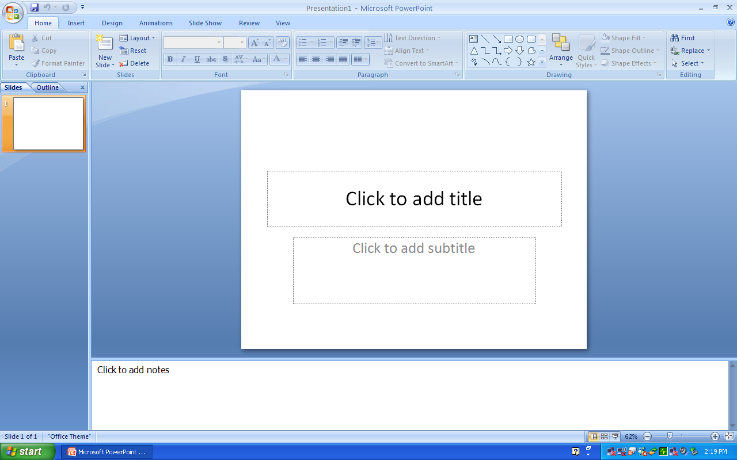
1
2
3
5

4

Screen Layout
Description of the Screen Layout
- Title bar
- Status bar
- Slide Pane: Displays a slide one at a time
- Short cut of slide views: Includes Normal View, Slide Sorter and Slide Show
- Notes Pane: Can be used for adding notes to the presentation

Creating a New Slide
- Click on the Microsoft Office Button
- Click on New
- Click on Blank Presentation
- Click on Create

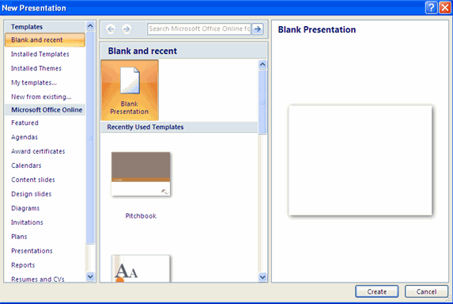

Slides can also be created by using in-built templates

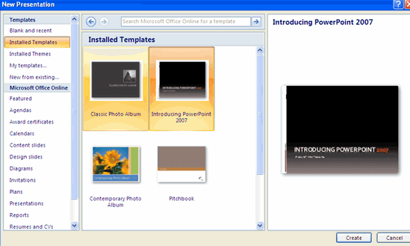

Office Themes
Themes are design templates that can be applied to the entire presentation consistently.

To add a Theme to the presentation,
- Select Home tab
- Click on Layout in Slides group

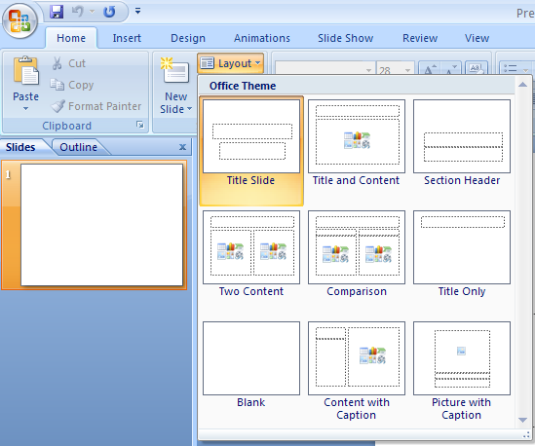

- Design your slides by selecting the designs below,

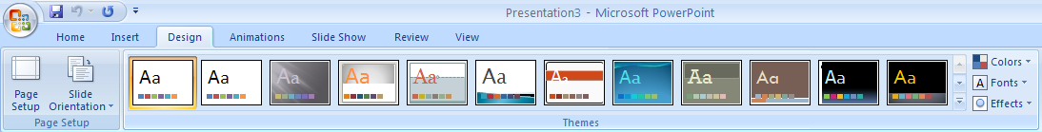

- Apply new colors to the theme,

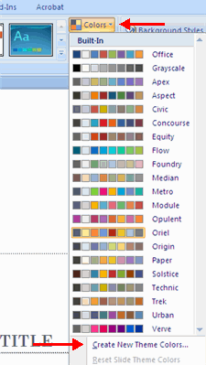

- Change the background of the slides by changing the background style option

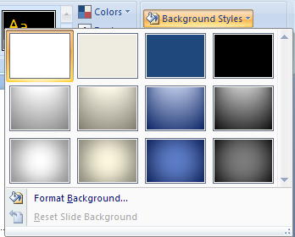

Slide Editing
New Slide created will have a text box feature to enter the text

To add a new text box,
- Select the slide where you want to place the text box
- On the insert tab, click on Text box
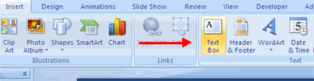
- Click on the slide and drag the cursor to expand the text box
- Type in the text

Copy, Cut & Paste
- Highlight the text that you want to copy / cut
- Click on Home tab
- Go to Clipboard
- Use the appropriate option
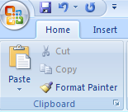

Save & Save As

- Click on Office Button
- Click on Save / Save As

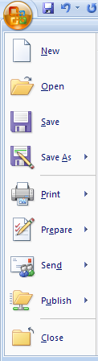

Text Format
To change the font style & Color of the text,

- Highlight the text
- Click on Home tab
- Go to Font group
- Click on the Font Style / Font color
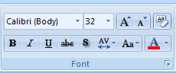

Word Art
You can insert decorative text in to your document by using Word Art

To Insert Word Art,
- Click on Insert Tab
- Go to Text group
- Click on Word Art
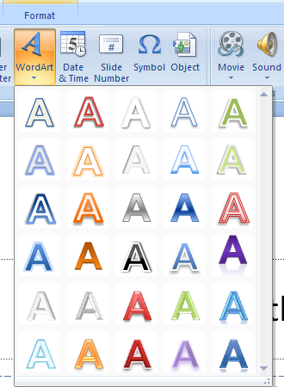

Note: Paragraph, Bullets & Numbering, Borders & Shades are same as in Word

Insert Options

Inserting an Embedded object

Objects are inserted for easy and quick access of the document or file

Steps to insert Objects are,

- Click on Insert option
- Click on Objects
- Either create a new file or

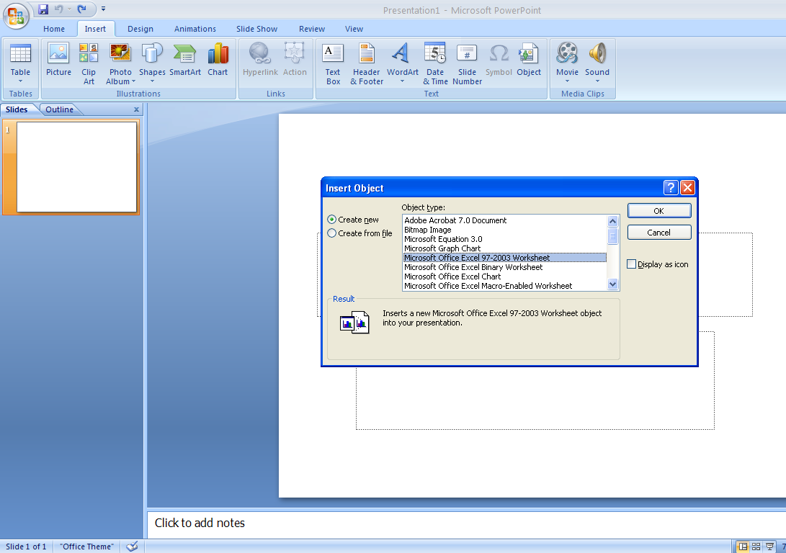

- Create from the existing file
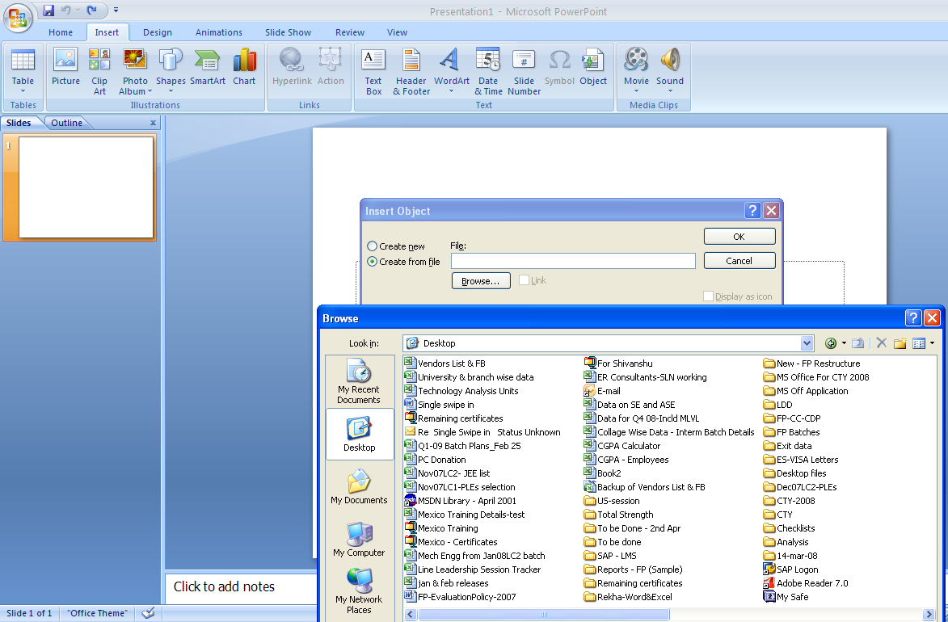

- Click on display as an icon
- Click on OK

Inserting Header & Footer

Steps to create Header & Footer are,
- Click on Insert
- Click on Header & Footer option
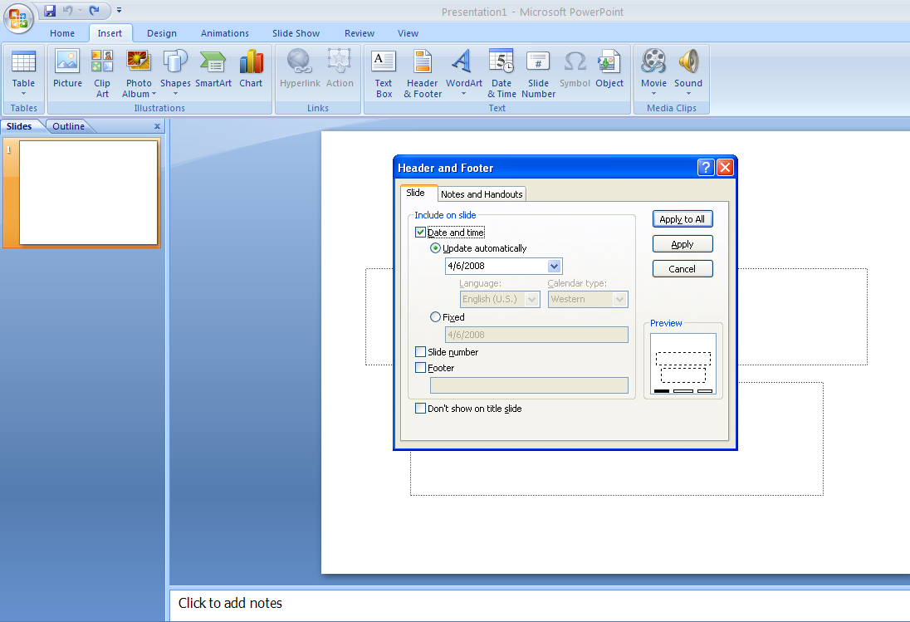

- Click on the appropriate options
- Click on Apply

Inserting Symbols
Steps to insert Symbols
- Click on Insert
- Click on Symbols
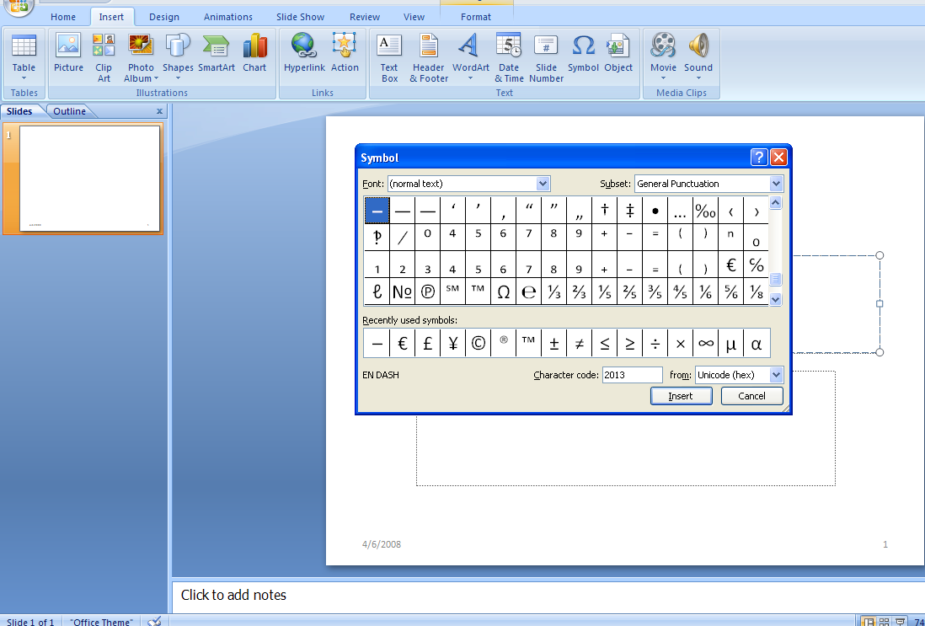

- Select the symbol
- Click on Insert

Slide Presentation

Audio Clips
To enhance your presentation, you can add sound clips to give more effects. Sound can be added either from the files available on your computer, a network, a Microsoft clip organizer, can be played from the audio CD and also be recorded.

To add sound clips,

- Select Insert Tab
- Go to Media Clips
- Click on Sound
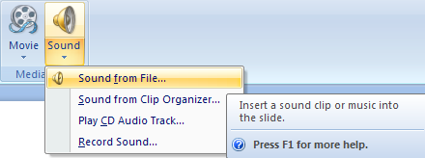

- Insert a sound clip from the appropriate location
- In the below snap shot, audio clip is created from the Clip Organizer
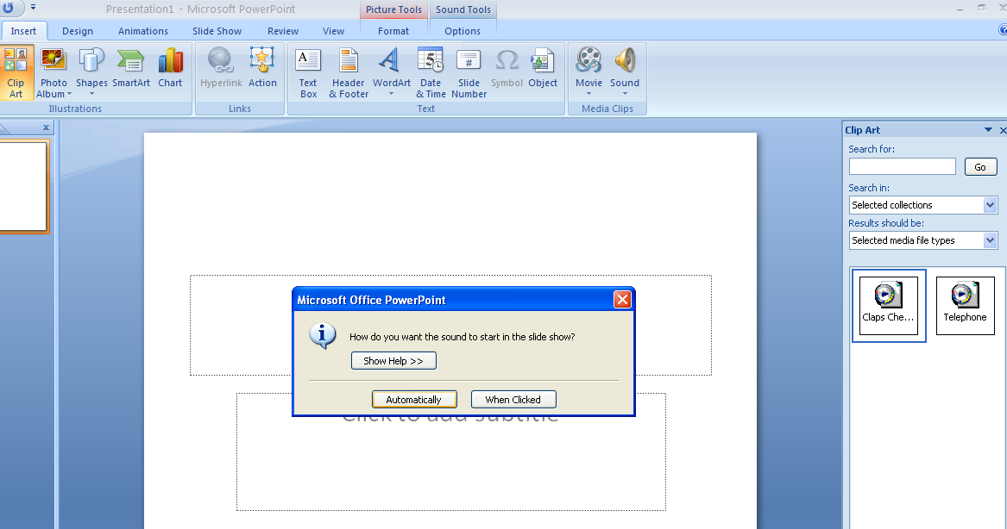

- When the audio clip is created, you will be asked, whether to play the sound automatically or whenever the user clicks on the sound icon
- Preview of the sound could be played
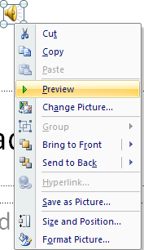

Video Clips
Movie clips (MPEG or AVI files) could be added to give extra effect to your presentation.

To add Video clips,

- Select Insert menu
- Go to Media Clips group and click the arrow under Movie
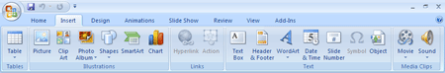
- Insert a Movie clip from the appropriate location
- Preview the inserted movie clip

Pictures
- Click the Insert Tab
- Click the Picture Button
- Browse to the picture from your files
- Click the name of the picture
- Click insert
- To move the graphic, click it and drag it to where you want it
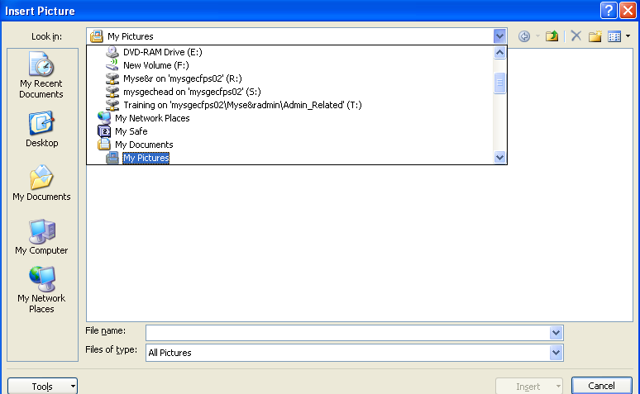

Clip Art
- Click the Insert Tab
- Click the Clip Art Button
- Search for the clip art using the search Clip Art dialog box
- Click the clip art
- To move the graphic, click it and drag it to where you want it
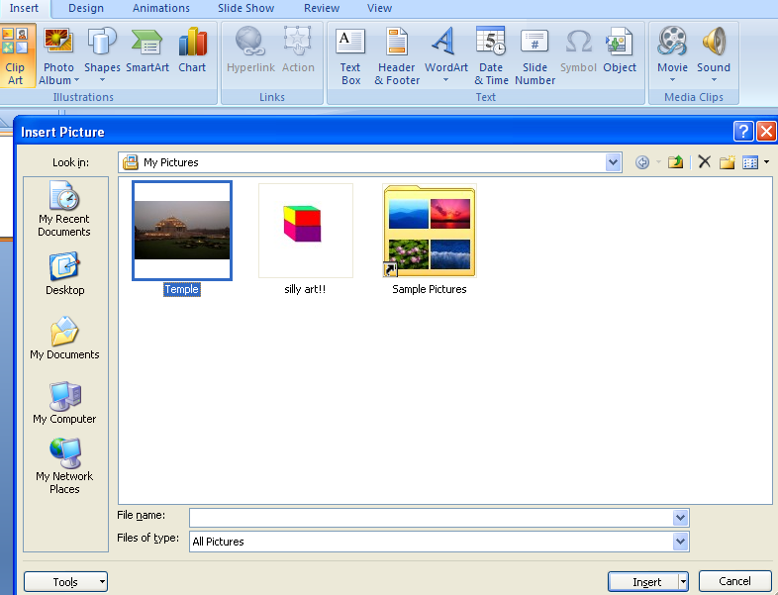

SmartArt
SmartArt is a feature allows you to choose from a variety of graphics, including flow charts, lists, cycles, and processes. To add SmartArt
To format the SmartArt:
- Click the SmartArt
- Click either the Design or the Format tab
- Click the SmartArt to add text and pictures.
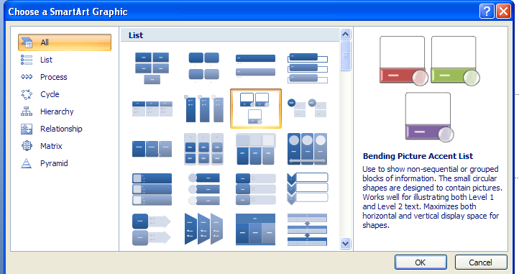
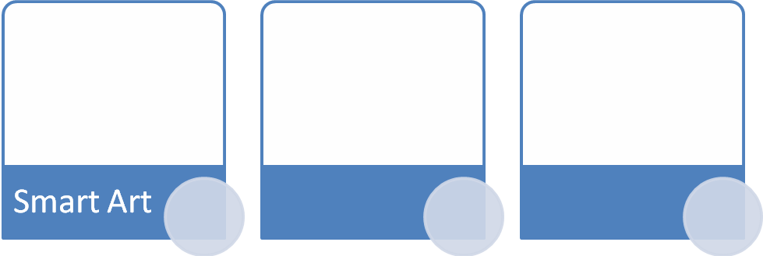

Photo Album
The photo album feature is new in PowerPoint 2007 and allows you to easily create a photo album to share pictures. To create a photo album:
- Select Insert Tab
- Click on the Photo Album button
- Click on New Photo Album
- Click on File/Disk to add pictures to the photo album
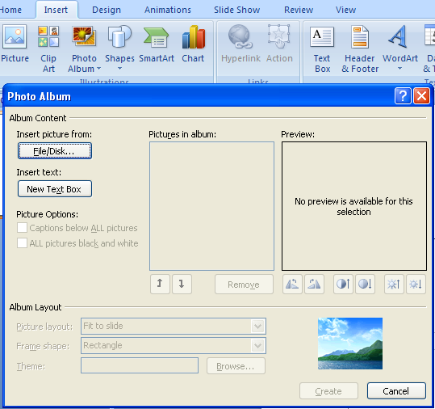

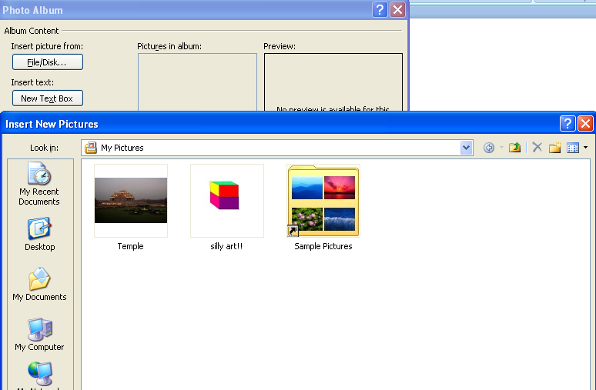
Move the pictures up and down in the order of the album but clicking the up/down arrows

Slide background
- Slide Orientation
- Designing the slides using Theme, Colors, Effects & background styles

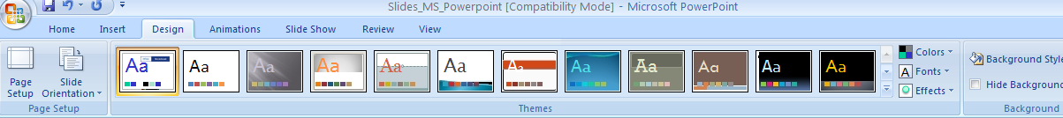

Master slide
A slide master is part of a template that stores the information, including placements of text and objects on a slide, text and object placeholder sizes, text styles, backgrounds, color themes, effects, and animation
To Create Master Slide,

  - Select View tab
  - Click on Slide Master
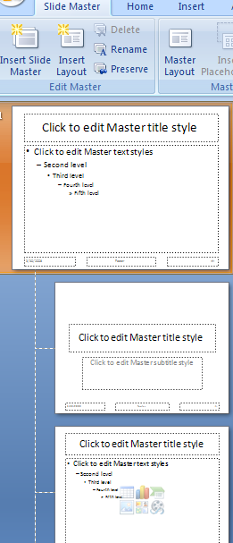

  - Design your master slide by editing the theme

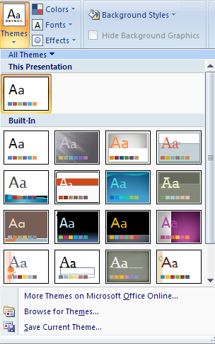

  - You can insert the new slide and delete the existing slide

Slide Transition
Transitions are effects that are in place when you switch your slide from one to the next.
Transitions can be,
- with Sounds and Speed
- advance slide by setting the timer

To add Slide Transition,

- Select the slide that you want to transition
- Click the Animations tab
- Choose the appropriate animation or click the Transition dialog box

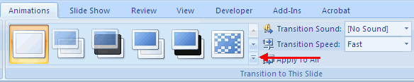

- Add sound by clicking the arrow next to Transition Sound

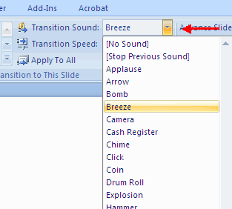

- Modify the transition speed by clicking the arrow next to Transition Speed
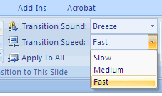

To apply transition to all slides, click on Apply To All tab

Slide Animation
Slide Animation gives special effect to the slides when you view the slides in slide show mode.
- Select the object
- Click the Animations tab on the Ribbon
- Click Custom Animation
- Click Add Effect
- Choose the appropriate effect

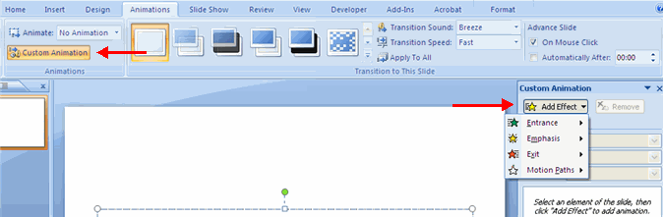

To preview the animation on a tab, click the preview on the animation tab

Slide Show
This option allows you to set preferences for how the slide show will be presented. The options include:
- Whether the show will run automatically or will be presented by a speaker
- The looping options
- Narration options
- Monitor resolutions

Record Narration
When you want to record narration for the slides,
- Click the Record Narration button
- Click Set Microphone Level to check the levels of audio input
- Click OK to record the narration
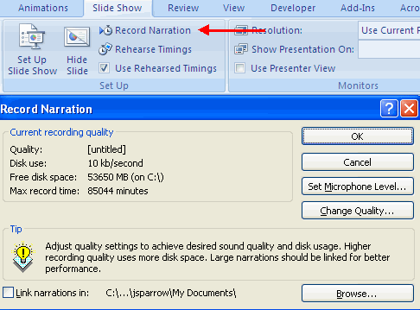
Rehearse Timings
Use Rehearsed Timings to rehearse the timings of slide with audio.
- Click the Rehearse Timings button
- Practice speaking and advance the slides as you would in the presentation
- When you have completed this click through the end of the slide
- Choose whether or not to keep this timing or to retry
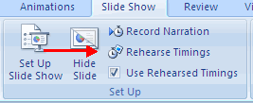

Create Speaker Notes
Speaker Notes can be added to allow you to create notes for each slide. To add speaker notes:
- Select the slide
- Click View
- Click Note Pages
- Click the Click to add Notes section of the screen
- Type in the Notes for that slide
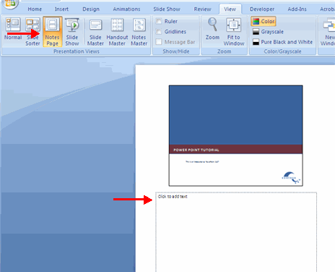

Different PowerPoint Views
PowerPoint has four mail views: Normal View, Slide Sorter View, Note Page View and Slide show view

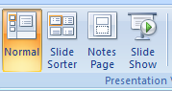

Normal View
This is the main editing view where you design and edit the presentation. This is the default view.
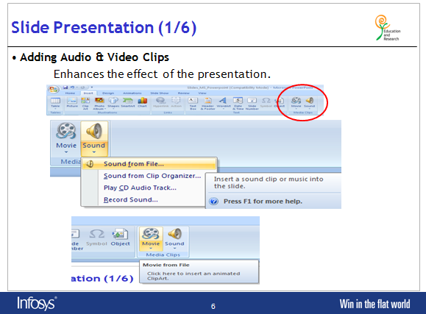

Slide Sorter
This is used to view the slides in thumbnail form.

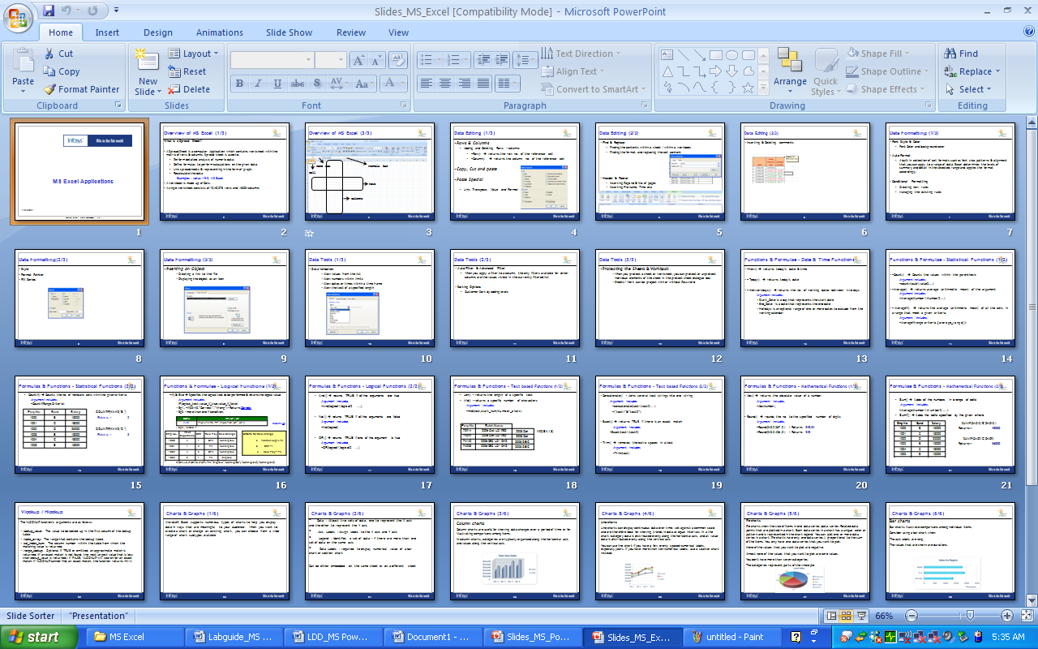

Notes Page View
You can view the notes added to the slide in full page,
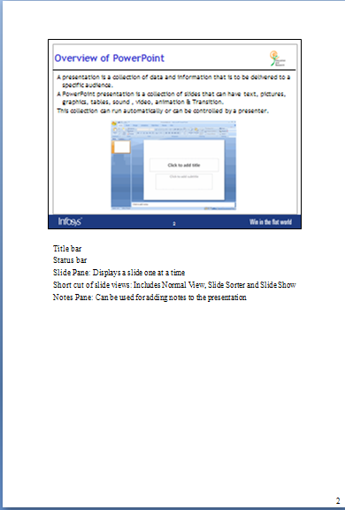

Slide Show View
This view takes up the full screen of the computer. You can run through the slides either by a mouse click or by using arrows keys in the key board. Animations are best seen in this view

Print a Presentation
There are many options for printing a presentation. They are:
- Slides: These are slides that you would see if you were showing the presentation, one slide per page
- Handouts: 1, 2, 3, 4, 6 or 9 per page, this option allows for more slides per page
- Notes Page: This includes the slides and the speaker notes
- Outline View: This will print the outline of the presentation
To access the print options:
- Click the Microsoft Office Button
- Click Print
- In the Print Dialog Box, click the arrow next to Print what
- Choose the format and click OK to print
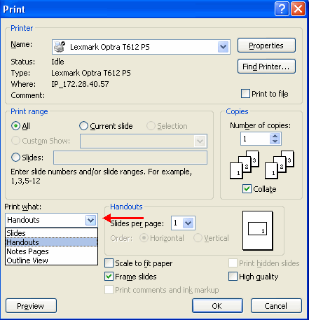
To print preview:
- Click the Microsoft Office Button
- Place the cursor over Print
- Click Print Preview
- Click the arrow next to Print What to change print options
- To print from Print Preview, click Print
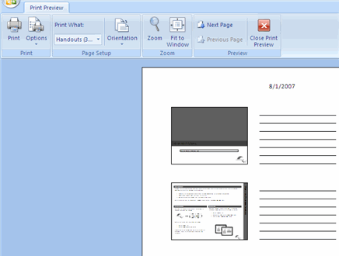
To Exit Print Preview:
- Click the Close Print Preview button
